# Hand calculations

Calculating the modes of the system by hand is complicated and depends on a number of variables. The modes are characterized by:

* Natural Frequency
* Modal Damping - no damping present in the current model
* Mode Shape

In order to calculate the values for those variables a method needs to be identified as suitable and applicable.

## Choose a method

There are a number of approaches that can be used in order to perform the hand calculations for finding the modes and natural frequencies of the system (Figure 1). Those include (and are not limited to):

* Euler–Bernoulli beam theory
* Transverse vibration of beams
* Lump mass matrix method

#### Figure 1: System geometry

This is a prove that there is more than one option to select from to analyze the system. But certain assumptions need to be made when using each method. Base on those assumptions and how realistic they are the final analysis of the system is influenced. The assumptions for **Euler–Bernoulli** and **Transverse vibration** are impractical in the current case. In order to use both of those method an assumption that that beam is straight needs to be made. Which is not a sufficient representation of the beam. Additional problem with both of these approaches is that the beam needs to be constrained and since the purpose of the project is to analysis free-free unconstrained beam it can be concluded that neither **Euler–Bernoulli** nor **Transverse vibration** are a good approach for analyzing the system.

**Lump mass matrix method** also has its flows such as the extraction of the mass and stiffness matrixes, but the assumptions made to solve the problems have lower impact on the final solution.

Taking into consideration the above implication to the final solution Lump mass matrix method was chosen for the analysis of the beam.

Methodology of the method:

* Extraction of the Mass matrix
* Extraction of the Local stiffness matrixes
* Assembly of the Global stiffness matrix
* Rearranging the Global stiffness matrix
* Reduction of the Global Stiffness matrix to the size of the mass matrix
* Extraction of the eigenvalues (frequency matrix) and eigenvectors (mode shapes) of the system

For the analysis MATLAB was used.

### Extraction of the Mass matrix

A custom function FindingMassMatrix that finds the mass of the individual elements of the beam has been created. The method that the function uses is based on $mass= ρV$. Where the density is known (Moodle 2020) and the Volume was calculated based on the geometry. The volume (example in figure 3) was calculated by finding the area (example in figure 2) of each element and multiplying it by the depth of each segment of the ZY cross sectional view of the beam. Hence the mass (example in figure 3) was also calculated for each element individually along with the total mass of the beam.

#### Figure 2: MATLAB code for Area of elements used in calculating the mass matrix

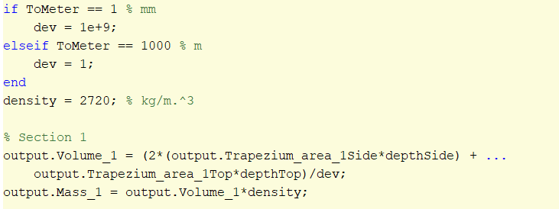

#### Figure 3: MATLAB code for Volume and mass of elements

From the masses of each section the mass matrix was constructed. The number of elements of the beam, as it can be seen from Figure 1, are 5 but since the number of nodes and the final size of the reduced global stiffness matrix are 6. A change to the value and the assembly of the mass matrix had to be done. The method used was to divide the mass of each element to its adjacent points (point mass) where each point will have half of the mass of its adjacent element(s). Example of the mass matrix can be seen in table 1 and the code for it in figure 4.

|  |  |  |  |  |  |  |  |  |  |  |  |  |  |  |  |  |  |  |  |  |  |  |  |  |  |  |  |  |  |  |  |  |  |  |  |  |
| --- | --- | --- | --- | --- | --- | --- | --- | --- | --- | --- | --- | --- | --- | --- | --- | --- | --- | --- | --- | --- | --- | --- | --- | --- | --- | --- | --- | --- | --- | --- | --- | --- | --- | --- | --- | --- |
| |  |  |  |  |  |  | | --- | --- | --- | --- | --- | --- | | (m1)/2 | 0 | 0 | 0 | 0 | 0 | | 0 | (m1)/2+(m2)/2 | 0 | 0 | 0 | 0 | | 0 | 0 | (m2)/2+(m3)/2 | 0 | 0 | 0 | | 0 | 0 | 0 | (m3)/2+(m4)/2 | 0 | 0 | | 0 | 0 | 0 | 0 | (m4)/2+(m5)/2 | 0 | | 0 | 0 | 0 | 0 | 0 | (m5)/2 | |

#### Table 1: Mass matrix

#### Figure 4: MATLAB code for Mass matrix of the beam

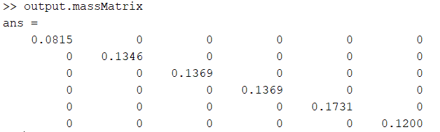

#### Figure 5: Mass matrix

### Extraction of the Local stiffness matrixes

The extraction of the individual Local stiffness matrixes has been completed using the following 2 custom functions:

* LocalStiffnessMatrix = StiffnessMatrix(output)
* beamMatrix = LocalBeamStiffnessMatrix(E, A, L, I, deg)

Generates the local stiffness matrixes for the whole system based on the generated output from the FindingMassMatrix function. The calculations of an individual local matrix is completed using the formula seen on Figure 2

#### Figure 6: Local Stiffness matrix

Where the Area, Length and degree of element along with the Second moment of Inertia of the beam are used.

### Assembly of the Global stiffness matrix

The assembly of the Global stiffness matrix is the normal way matrixes are constructed by addition taking into consideration the position of individual nodes. Position of different section of the Local stiffness matrixes inside the Global stiffness matrix can be seen on table 2.

|  |  |  |  |  |  |  |  |  |  |  |  |  |  |  |  |  |  |  |  |  |  |  |  |  |  |  |  |  |  |  |  |  |  |  |  |  |  |  |  |  |  |  |  |  |  |  |  |  |  |  |  |  |  |  |  |  |  |  |  |  |  |  |  |  |  |  |  |  |  |  |  |  |  |  |  |  |  |  |  |  |  |  |  |  |  |  |  |  |  |  |  |  |  |  |  |  |  |  |  |  |  |  |  |  |  |  |  |  |  |  |  |  |  |  |  |  |  |  |  |  |  |  |  |  |  |  |  |  |  |  |  |  |  |  |  |  |  |  |  |  |  |  |  |  |  |  |  |  |  |  |  |  |  |  |  |  |  |  |  |  |  |  |  |  |  |  |  |  |  |  |  |  |  |  |  |  |  |  |  |  |  |  |  |  |  |  |  |  |  |  |  |  |  |  |  |  |  |  |  |  |  |  |  |  |  |  |  |  |  |  |  |  |  |  |  |  |  |  |  |  |  |  |  |  |  |  |  |  |
| --- | --- | --- | --- | --- | --- | --- | --- | --- | --- | --- | --- | --- | --- | --- | --- | --- | --- | --- | --- | --- | --- | --- | --- | --- | --- | --- | --- | --- | --- | --- | --- | --- | --- | --- | --- | --- | --- | --- | --- | --- | --- | --- | --- | --- | --- | --- | --- | --- | --- | --- | --- | --- | --- | --- | --- | --- | --- | --- | --- | --- | --- | --- | --- | --- | --- | --- | --- | --- | --- | --- | --- | --- | --- | --- | --- | --- | --- | --- | --- | --- | --- | --- | --- | --- | --- | --- | --- | --- | --- | --- | --- | --- | --- | --- | --- | --- | --- | --- | --- | --- | --- | --- | --- | --- | --- | --- | --- | --- | --- | --- | --- | --- | --- | --- | --- | --- | --- | --- | --- | --- | --- | --- | --- | --- | --- | --- | --- | --- | --- | --- | --- | --- | --- | --- | --- | --- | --- | --- | --- | --- | --- | --- | --- | --- | --- | --- | --- | --- | --- | --- | --- | --- | --- | --- | --- | --- | --- | --- | --- | --- | --- | --- | --- | --- | --- | --- | --- | --- | --- | --- | --- | --- | --- | --- | --- | --- | --- | --- | --- | --- | --- | --- | --- | --- | --- | --- | --- | --- | --- | --- | --- | --- | --- | --- | --- | --- | --- | --- | --- | --- | --- | --- | --- | --- | --- | --- | --- | --- | --- | --- | --- | --- | --- | --- | --- | --- | --- | --- | --- | --- | --- | --- | --- | --- | --- | --- | --- | --- |
| |  |  |  |  |  |  |  |  |  |  |  |  |  |  |  |  |  |  | | --- | --- | --- | --- | --- | --- | --- | --- | --- | --- | --- | --- | --- | --- | --- | --- | --- | --- | | K1 | | | K1 | | |  |  |  |  |  |  |  |  |  |  |  |  | |  |  |  |  |  |  |  |  |  |  |  |  | |  |  |  |  |  |  |  |  |  |  |  |  | | K1 | | | K1 + K2 | | | K2 | | |  |  |  |  |  |  |  |  |  | |  |  |  |  |  |  |  |  |  | |  |  |  |  |  |  |  |  |  | |  |  |  | K2 | | | K2 + K3 | | | K3 | | |  |  |  |  |  |  | |  |  |  |  |  |  |  |  |  | |  |  |  |  |  |  |  |  |  | |  |  |  |  |  |  | K3 | | | K3 + K4 | | | K4 | | |  |  |  | |  |  |  |  |  |  |  |  |  | |  |  |  |  |  |  |  |  |  | |  |  |  |  |  |  |  |  |  | K4 | | | K4 + K5 | | | K5 | | | |  |  |  |  |  |  |  |  |  | |  |  |  |  |  |  |  |  |  | |  |  |  |  |  |  |  |  |  |  |  |  | K5 | | | K5 | | | |  |  |  |  |  |  |  |  |  |  |  |  | |  |  |  |  |  |  |  |  |  |  |  |  | |

#### Table 2: Assembly of Global stiffness matrix

#### Figure 7: MATLAB code for the assembled Global stiffness matrix

Additionally, the first and the last y values are changed to be 50 to their original value. That represents the string support present in the experiment.

### Rearranging the Global stiffness matrix

The Global Stiffness matrix needs to be reduced to size of 6x6 because only the displacement in y is of interest and due to the nature of the experiment. In the experiment forced vibration was introduced in the y-axis only. Even if the values for the x and theta are found there is not experimental data it can be compared to. Additionally, rotation is not of interest since i (rotational translation) is equivalent 0 because the inertia of point mass is zero. In order to extract the reduced global stiffness matrix, it first needs to be rearranged so that it contains the y-values first, then the x and theta values. The rearrangement is completed by pulling separately the y rows and the y columns (as seen in figure 10).

#### Figure 8: MATLAB code for creating order variable



#### Figure 9: Order variable

The ordered variable represents the number of the individual rows and columns by the specific order that they will be rearranged.

Картина, която съдържа екранна снимка

Описанието е генерирано автоматично

#### Figure 10: MATLAB code for the newly rearranged global stiffness matrix

The zero values of the Global stiffness matrix are replaced with 1e-7 value to prevent MATLAB for complaining the returning errors when computing the reduction matrix. The value of 1e-7 is the smallest value that satisfies MATLAB and doesn’t influence the further computations.

### Reduction of the Global Stiffness matrix to the size of the mass matrix

The reduction of the Rearranged Global stiffness matrix is based on using the Partitioned matrix method. The blocks of the Partitioned matrix can be seen in figure 11. The matrix consists of:

* D – all the parameters of interest (6x6)
* E – all the parameters that are not of interest (12x12)
* F – interactions matrix (6x12 or 12x6)

|  |  |
| --- | --- |
| D | F |
|
|
|
|
|
| transposed(F) | E |
|
|
|
|
|
|
|
|
|
|
|

#### Figure 11: Partitioned matrix blocks

The equation applied to this matrix is K* = D-F*E-1*FT as it can be seen in figure 12.

#### Figure 12: MATLAB code for the reduction matrix

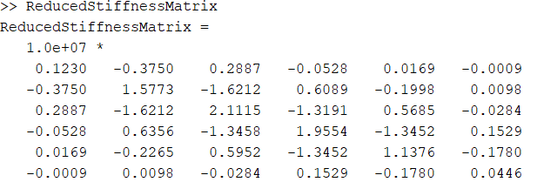

#### Figure 13: Reduced stiffness matrix

### Extraction of the eigenvalues (frequency matrix) and eigenvectors (mode shapes) of the system

Using the reduced stiffness matrix and the mass matrix the eigenvalues (frequency matrix) and eigenvectors (mode shapes) of the system are calculated. The eig function is applied to the Ω = M-1*K where M is the mass matrix, K – reduced global stiffness matrix and Ω is the frequency matrix. The frequency matrix is then rearranged to a column vector containing the squared values of the Natural frequencies. The Natural frequencies are then computed in Hz as seen in figure 14.

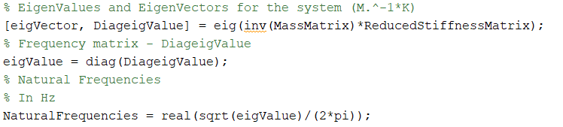

#### Figure 14: MATLAB code that extract the frequency matrix and the mode shapes

Картина, която съдържа бутилка, маса, снимка, екран

Описанието е генерирано автоматично

#### Figure 15: Mode shapes



#### Figure 16: Natural frequency in Hz

The last 2 value from the eigen values are ignored because they are to small and it is not expected to see a mode shape at such low frequency which can be seen in table 3.

|  |  |  |  |
| --- | --- | --- | --- |
| 2962.2 | 1819.5 | 681.69 | 278.65 |

#### Table 3: Natural Frequencies for the different modes

## References

Moodle (2020) Geometry and beam properties

[Online] available from < <https://cumoodle.coventry.ac.uk/pluginfile.php/3171749/mod_resource/content/1/Beams%20Dimensions%20%20Material%20Properties.pdf>> (5 Mar 2020)

Moodle (2020a) CW-B Brief

[Online] available from <<https://cumoodle.coventry.ac.uk/pluginfile.php/3267641/mod_resource/content/3/326MAE%20CWB%20-%20Dynamics.pdf>> (5 Mar 2020)

Moodle (2020b) Assignment Brief

[Online] available from <<https://cumoodle.coventry.ac.uk/pluginfile.php/3174530/mod_resource/content/2/326MAE%20CW%20-%20Assignment%20Brief.pdf>> (20 Jan 2020)

$$\begin{matrix}\frac{EA}{L}c^{2}+\frac{12EI}{L^{3}}s^{2} & \frac{EA}{L}cs-\frac{12EI}{L^{3}}cs & -\frac{6EI}{L^{2}}s \\ \frac{EA}{L}cs-\frac{12EI}{L^{3}}cs & \frac{EA}{L}s^{2}+\frac{12EI}{L^{3}}c^{2} & \frac{6EI}{L^{2}}c \\ -\frac{6EI}{L^{2}}s & \frac{6EI}{L^{2}}c & \frac{4EI}{L}\end{matrix} \begin{matrix}-\frac{EA}{L}c^{2}-\frac{12EI}{L^{3}}s^{2} & -\frac{EA}{L}cs+\frac{12EI}{L^{3}}cs & -\frac{6EI}{L^{2}}s \\ -\frac{EA}{L}cs+\frac{12EI}{L^{3}}cs & -\frac{EA}{L}s^{2}-\frac{12EI}{L^{3}}c^{2} & \frac{6EI}{L^{2}}c \\ \frac{6EI}{L^{2}}s & -\frac{6EI}{L^{2}}c & \frac{2EI}{L}\end{matrix}$$

$$\begin{matrix}-\frac{EA}{L}c^{2}-\frac{12EI}{L^{3}}s^{2} & -\frac{EA}{L}cs+\frac{12EI}{L^{3}}cs & \frac{6EI}{L^{2}}s \\ -\frac{EA}{L}cs+\frac{12EI}{L^{3}}cs & -\frac{EA}{L}s^{2}-\frac{12EI}{L^{3}}c^{2} & -\frac{6EI}{L^{2}}c \\ -\frac{6EI}{L^{2}}s & \frac{6EI}{L^{2}}c & \frac{2EI}{L}\end{matrix} \begin{matrix}\frac{EA}{L}c^{2}+\frac{12EI}{L^{3}}s^{2} & \frac{EA}{L}cs-\frac{12EI}{L^{3}}cs & \frac{6EI}{L^{2}}s \\ \frac{EA}{L}cs-\frac{12EI}{L^{3}}cs & \frac{EA}{L}s^{2}+\frac{12EI}{L^{3}}c^{2} & -\frac{6EI}{L^{2}}c \\ \frac{6EI}{L^{2}}s & -\frac{6EI}{L^{2}}c & \frac{4EI}{L}\end{matrix}$$